AutoSAP SD Post Functional Checks
Solution Manager signatures signify that approvers have read, understood, and agrees with the content of this document.
Name | Job Title and Role
Akoju Sharanya | The author is signing to confirm that this document has been prepared in accordance with an approved document management process, that content is consistent with the deliverable definition found in Specify System, that relevant input from any contributory authors has been included and that an appropriate review / editing process has been conducted.
Akoju Sharanya | The Developer (selected by the Project Manager as responsible for the design of the system) is signing to confirm that the Design Specification is fit for purpose, that it will deliver a computer system that satisfies the System Requirements and that it will be used for the development or configuration of the computer system

Table of Contents
1 Introduction 3
2 Definition/Acronyms 3
3 General Statement of Design 3
3.1 Assumptions 3
4 References 3
5 Platform Architecture and Environment 3
6 Software Architecture 4
6.1 Generic Solution Details 4
7 System Operation Specification 10
8 Data 10
9 Security 10
10 Revision History 10
11 Appendices 10
12 Appendix Program-Logic 11

Introduction
The Sales & Distribution (SD) team will be verifying sales order delivery, reports, batch jobs IDocs etc., through transaction codes such as WE02, SM37, VA03, VF03, XD03, ZSD_PRICE_CHG_REPORT, ZSD_SOBOOK, and ZSD_SOSTATUS for Post Functional Checks. This document describes the automated process of these transactions for post functional checks.

Definition/Acronyms
Item | Definition
SAP | Systems Applications and Products
SID | System ID

General Statement of Design
Design methodology/principles | This task is developed to overcome the manual effort and time spent on post functional checks. The scripts are developed for end-end execution of notifying the status of various T-Codes for post functional checks.  The script logs into the RBP system and executes various T-Codes such as WE02, SM37, VA03, VF03, XD03, ZSD_PRICE_CHG_REPORT, ZSD_SOBOOK, and ZSD_SOSTATUS to retrieve their statuses. It captures screenshots of both successful and error cases, compiles them into a Word document, and sends an email with the document attached to designated team members.
Tools + version | Python 3.10.11, Pandas, SAP GUI 760, SMTP mail.
Programming standards | GSK Programming Standards.

Assumptions
Assuming all the t-codes are working fine

References
None

Platform Architecture and Environment
Python 3.10.11

Software Architecture
Element ID | Developed Software Unit name | ID | Programming Language(s) | Description of Purpose
DS/SD_SAP-CC/0001 | Program | autosapMain.py | Python | This is the main file which imports remaining files to perform the SAP actions
DS/SD_SAP-CC/0002 | Program | IDOC.py | Python | This file checks for IDOC failures
DS/SD_SAP-CC/0003 | Program | sm37.py | Python | This file will checks for batch jobs of sm37 t-code.
DS/SD_SAP-CC/0004 | Program | va03.py | Python | This file checks for display sales document and document flow.
DS/SD_SAP-CC/0005 | Program | vf03.py | Python | This file checks for billing document and print preview
DS/SD_SAP-CC/0006 | Program | xd03.py | Python | This file checks for customer sales area data.
DS/SD_SAP-CC/0007 | Program | ZSD_PRICE_CHG.py | Python | This file checks for ZSD_PRICE_CHG  Price change report.
DS/SD_SAP-CC/0008 | Program | ZSD_SOBOOK.py | Python | This file checks for sales order book report.
DS/SD_SAP-CC/0009 | Program | ZSD_SOSTATUS.py | Python | This file checks for sales order status report.
DS/SD_SAP-CC/00010 | Program | sender.py | Python | This file sends an email to the specified recipients with the attached evidence.
DS/SD_SAP-CC/00011 | Program | logon.py | Python | This file logs into the SAP
DS/SD_SAP-CC/00012 | Program | cc.py | Python | This is the file where credentials are read.

Generic Solution Details
Authorisations
No Authorisations checks implemented as Authorisations are derived from user.
Message Class and Messages:
NA
Manual Process:
SYSTEM: RBP system
T-Codes : WE02, SM37, VA03, VF03, XD03, ZSD_PRICE_CHG_REPORT, ZSD_SOBOOK, and ZSD_SOSTATUS
Step1: login to RBP system by giving the credentials and enter
Enter the T-Code ‘sm37’ and give the following details:-
{"JOBNAME": "*C64*", "USERNAME": "*"},
{"JOBNAME": "*BACK*", "USERNAME": "*"},
{"JOBNAME": "*", "USERNAME": "*", "ABAPNAME": "SDBILLDL"},
{"JOBNAME": "*", "USERNAME": "*", "ABAPNAME": "RVV50R10C"} & click Execute button & take the Job Overview screenshot which is shown in below pictures.
Repeat this steps for next 3 Jobnames.
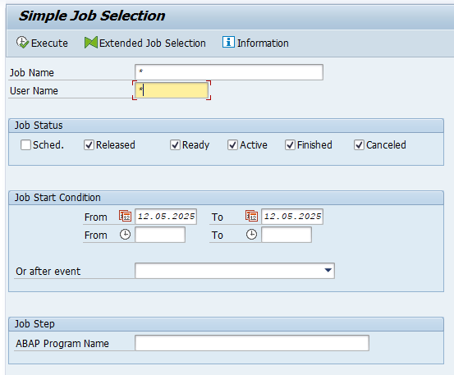 | 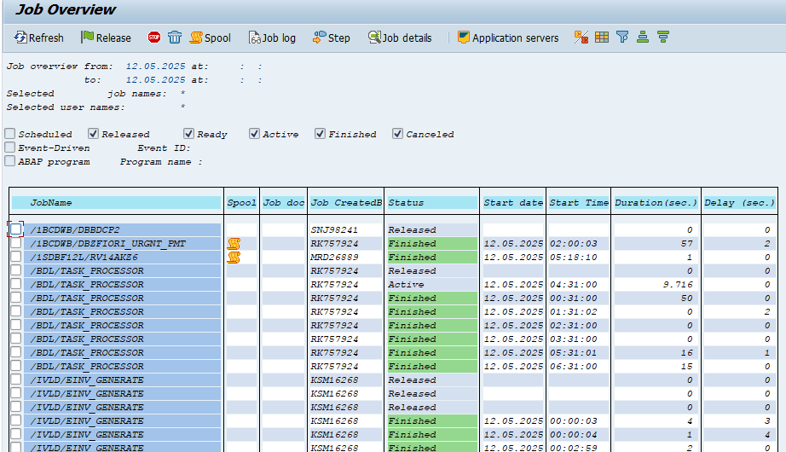

Step2: Enter T-code /nwe02, and provide the Basic types as "ORDERS05", "ORDERRSP", and "INVOIC". Click the Execute button.
Take a screenshot of the IDoc list.
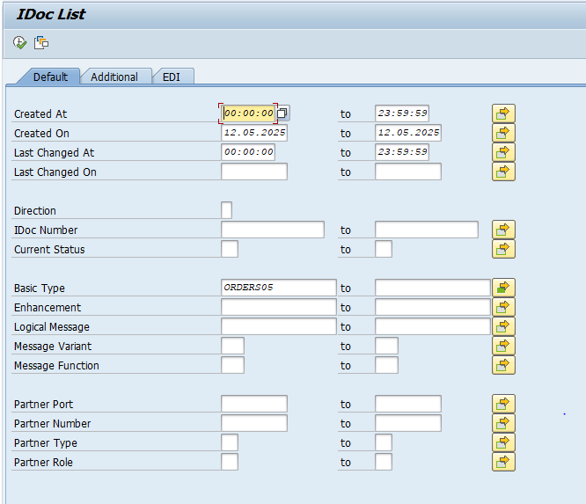 | 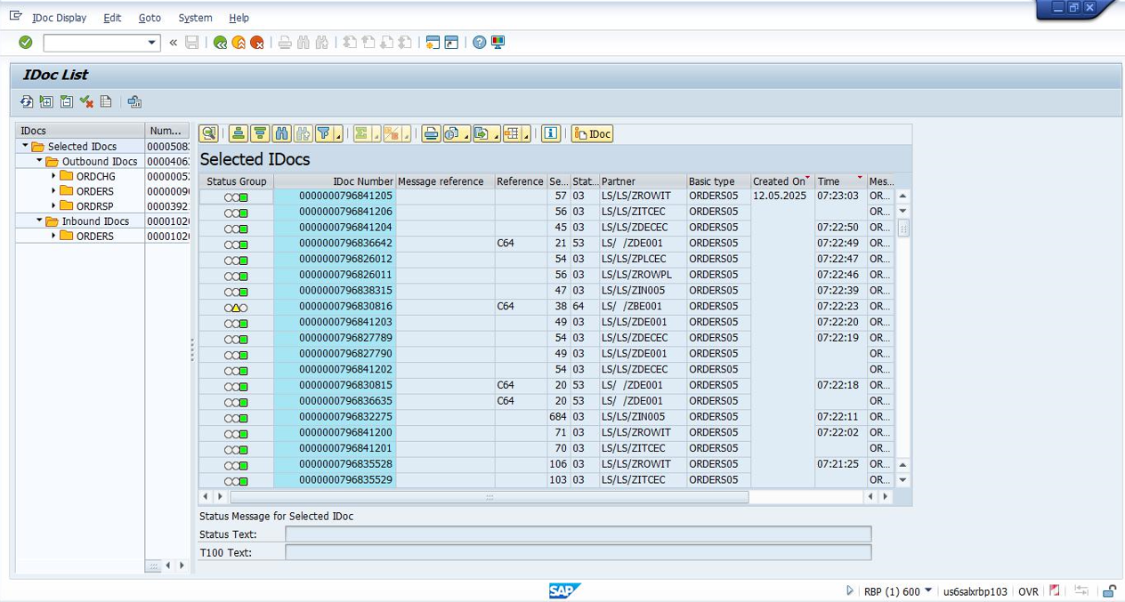

Step3: Enter the T-code /nva05n, provide the order type as ZEOR and set the document date to the last 1 week. Press the Execute button. This will display the document number. Copy the document number and navigate to T-code /nva03. Enter the copied document number and press Enter. This will display the sales document. Take a screenshot of the display.
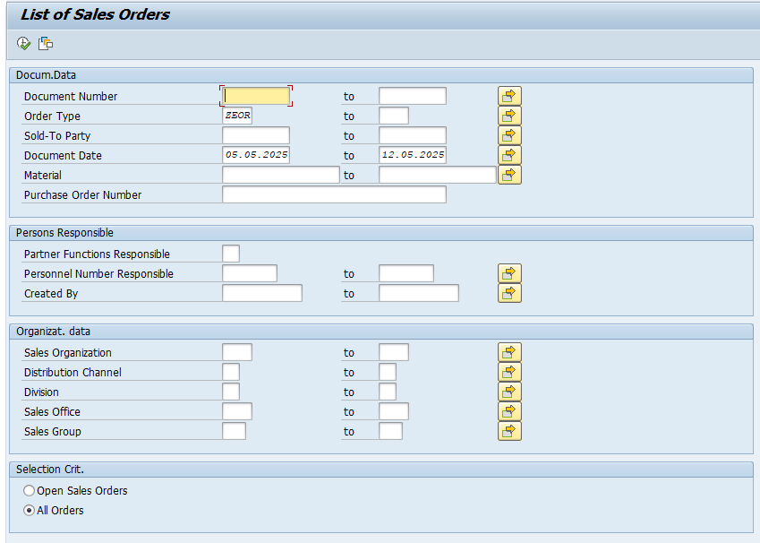 | 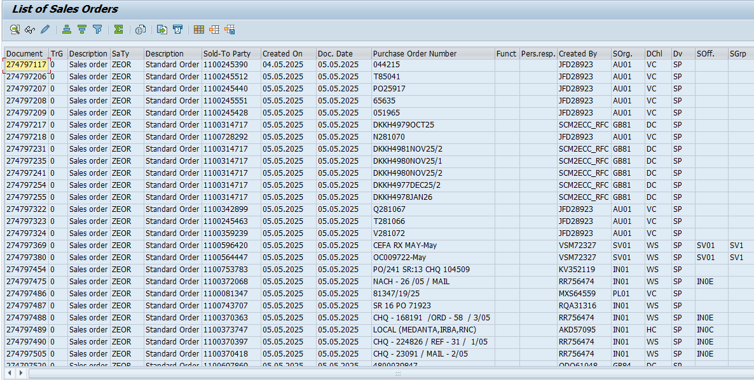
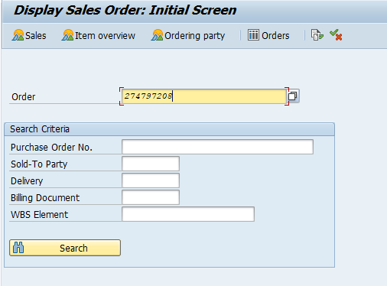 | 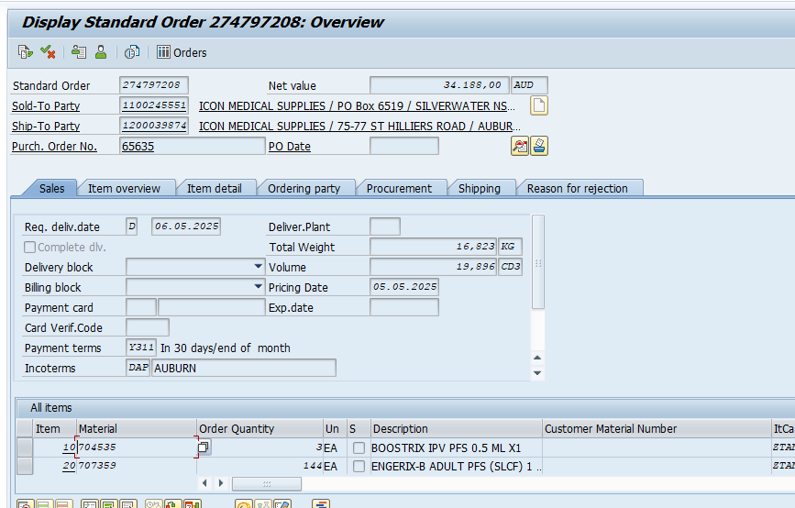

Step4: Go to /nse16n T-Code and enter the table name NAST.
Provide the following input values:
- Application: V3
- Message Type: ZRD0
- Created On: Last 1 week
Press Enter to retrieve the document number.
Next, go to /nvf03 T-Code, paste the copied document number, and press Enter to display the billing document. Take a screenshot.
Now, go to Billing Document → Issue Output To and press Enter to view the invoice layout. Take a screenshot, and also take a screenshot of the Print Preview.

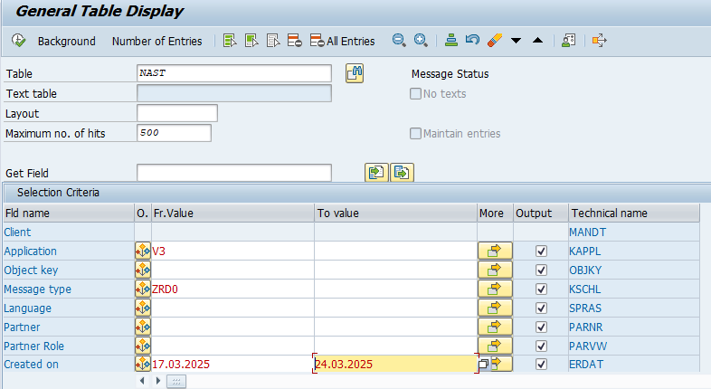 | 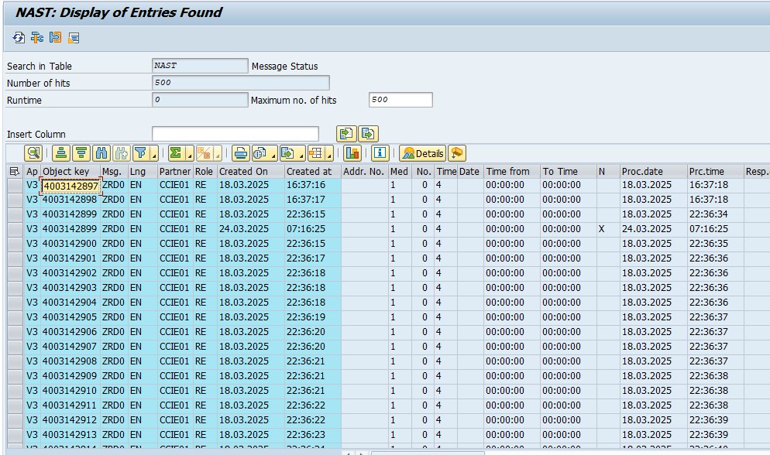
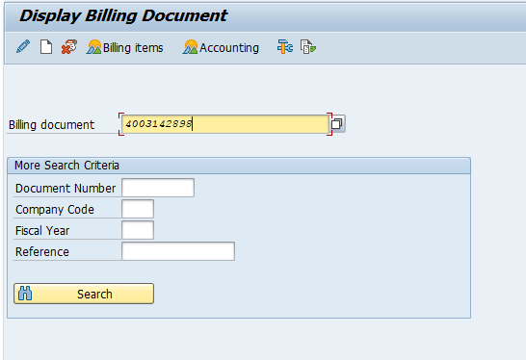 | 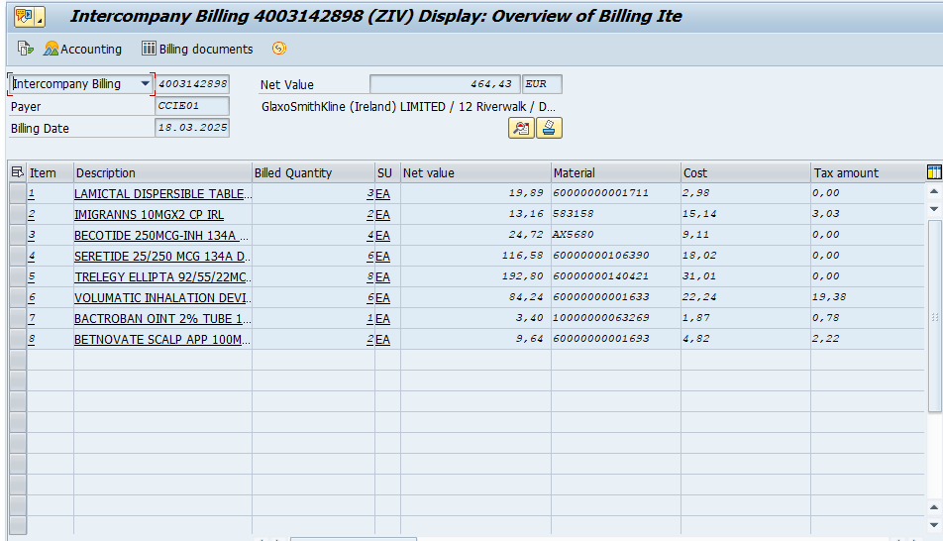
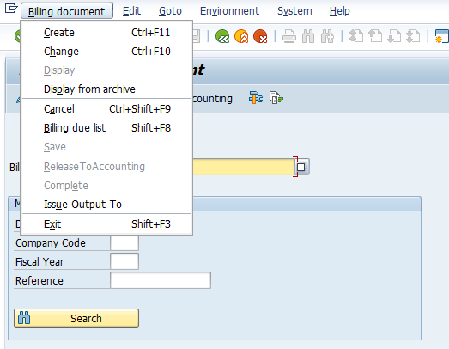 | 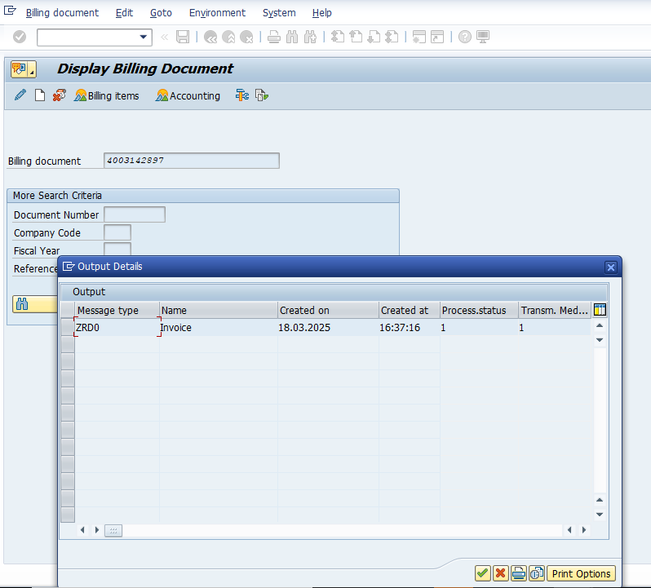
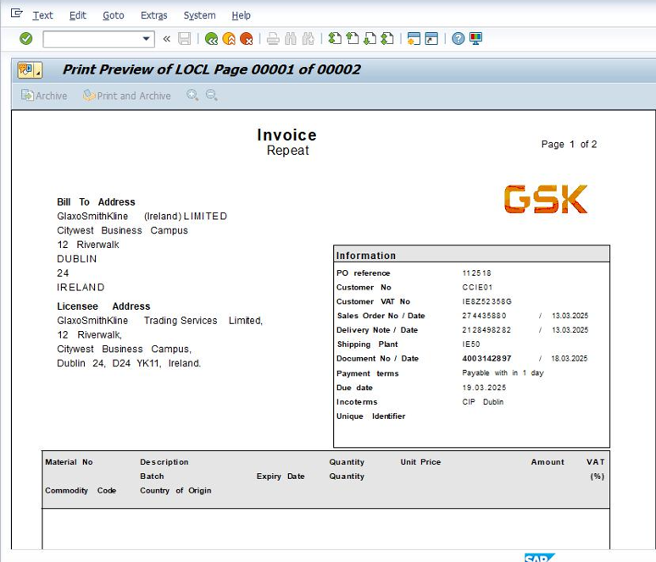

Step5: Copy the Sold-to Party number from the VA03 T-Code. Then go to /nXD03 T-Code, enter the Sold-to Party number, and press Enter. This will display the Customer Sales Area Data.
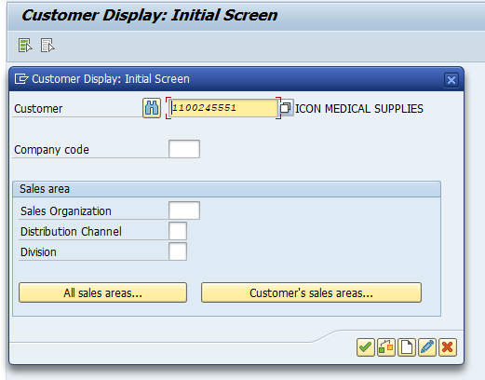 | 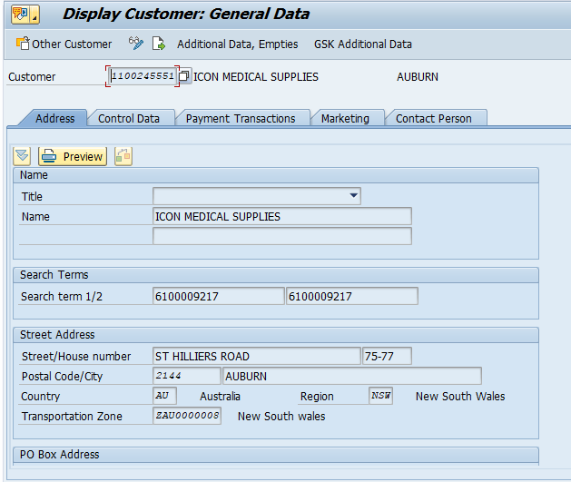
Step6:go to /nvk13 T-Code, click condition information, and take the screenshot of Gross price
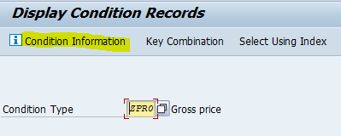 | 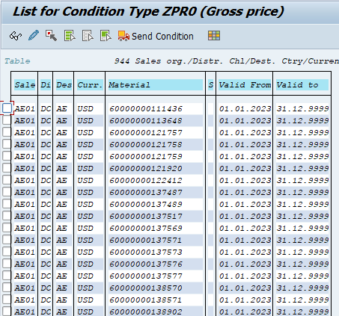
Step7: Go to /nZSD_PRICE_CHG_REPORT T-code, enter the date range for the last one week, provide the Condition Type as ZPR0, then execute.
Take a screenshot of the Price Record Change Report.
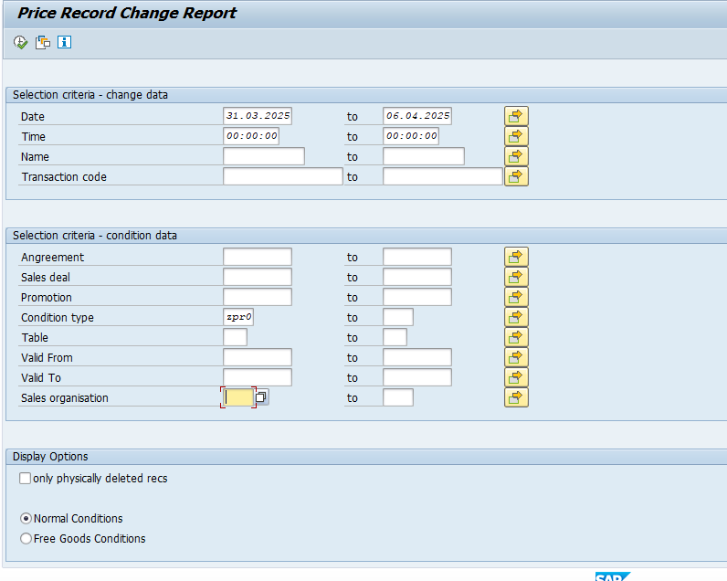 | 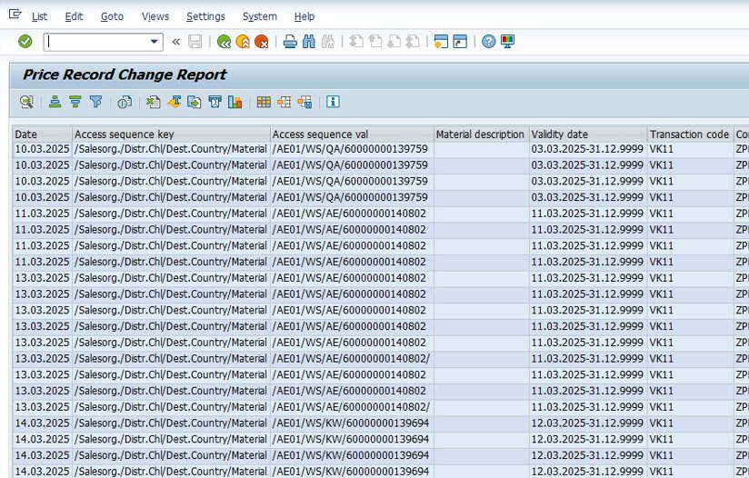

Step8: Go to /nZSD_SOBOOKT-code, enter the date range for the last one week, provide the Sales Organisation, then execute, this gives you sales order book
Take a screenshot of the Sales Order Book.
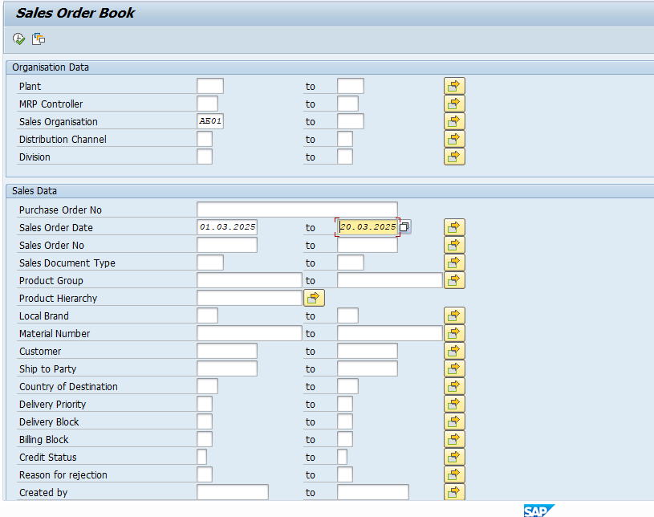 | 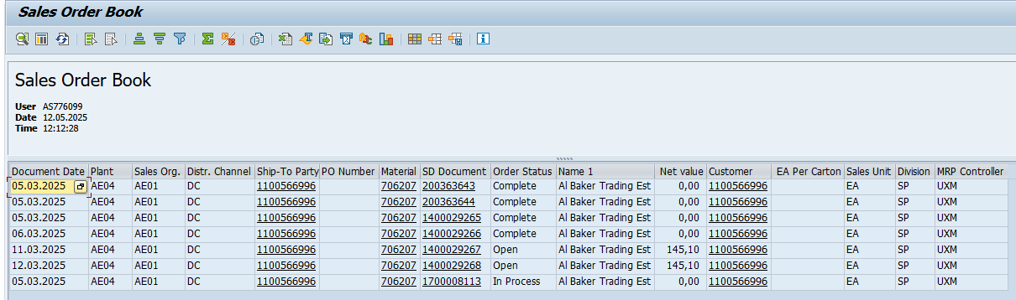

Step9: Go to /nZSD_SOSTATUS T-code, enter the date range for the last one week, provide the Sales Organisation, then execute, this gives you sales order status report
Take a screenshot of the Sales Order Status Report.
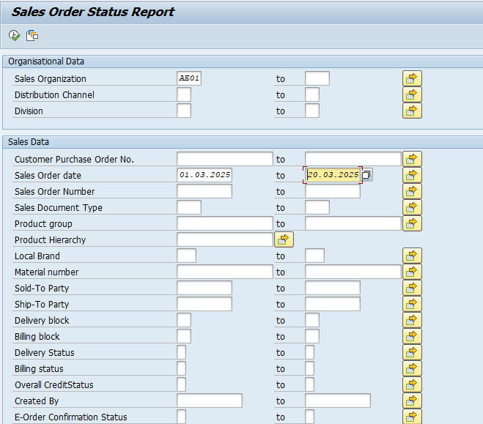 | 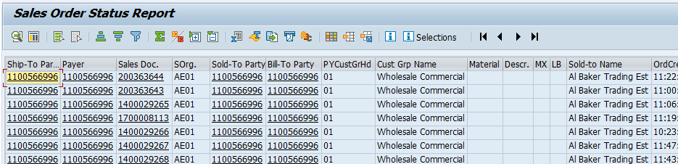
Input Format
NA
Output Format
NA
Output Medium
Print
Screen Summary
NA
Business Logic:
For detailed specification of the development please refer to Appendix – Program Logic
Run Mode
Foreground

System Operation Specification
NA

Data
NA

Security
NA

Revision History
Version | Source |  | Reason For Revision
Version | Deployment | BAU | Reason For Revision
1.0 | May-2025. | NA | This is the first issue of the document and initial version created for AutoSAP_001.

Appendices

Appendix – Selection Screen Definitions
NA

Appendix – Screen Layout Definition
NA

Appendix – Program Logic

Element ID | Logic Description
Autosap_SD Post Functional Checks | 1.Enter the T-Code ‘sm37’ and give the following details:-  {"JOBNAME": "*C64*", "USERNAME": "*"},  {"JOBNAME": "*BACK*", "USERNAME": "*"},  {"JOBNAME": "*", "USERNAME": "*", "ABAPNAME": "SDBILLDL"},  {"JOBNAME": "*", "USERNAME": "*", "ABAPNAME": "RVV50R10C"} &  click Execute button & take the Job Overview screenshot which is shown in below pictures.  Repeat this steps for next 3 Jobnames.  2. Enter T-code /nwe02, and provide the Basic types as "ORDERS05", "ORDERRSP", and "INVOIC". Click the Execute button.  Take a screenshot of the IDoc list.  3. Enter the T-code /nva05n, provide the order type as ZEOR and set the document date to the last 1 week. Press the Execute button. This will display the document number. Copy the document number and navigate to T-code /nva03. Enter the copied document number and press Enter. This will display the sales document. Take a screenshot of the display.  4. Go to /nse16n T-Code and enter the table name NAST.  Provide the following input values:  - Application: V3  - Message Type: ZRD0  - Created On: Last 1 week  Press Enter to retrieve the document number.  Next, go to /nvf03 T-Code, paste the copied document number, and press Enter to display the billing document. Take a screenshot.  Now, go to Billing Document → Issue Output To and press Enter to view the invoice layout. Take a screenshot, and also take a screenshot of the Print Preview.  5. Copy the Sold-to Party number from the VA03 T-Code. Then go to /nXD03 T-Code, enter the Sold-to Party number, and press Enter. This will display the Customer Sales Area Data.  6. go to /nvk13 T-Code, click condition information, and take the screenshot of Gross price  7. Go to /nZSD_PRICE_CHG_REPORT T-code, enter the date range for the last one week, provide the Condition Type as ZPR0, then execute.  Take a screenshot of the Price Record Change Report.  8. Go to /nZSD_SOBOOKT-code, enter the date range for the last one week, provide the Sales Organisation, then execute, this gives you sales order book  Take a screenshot of the Sales Order Book.  9. Go to /nZSD_SOSTATUS T-code, enter the date range for the last one week, provide the Sales Organisation, then execute, this gives you sales order status report  Take a screenshot of the Sales Order Status Report.  10.An email will be sent with evidences attached in the Word format for both success and failures cases.

Appendix – Output Layout Details
NA

Appendix – Sample Output Formats
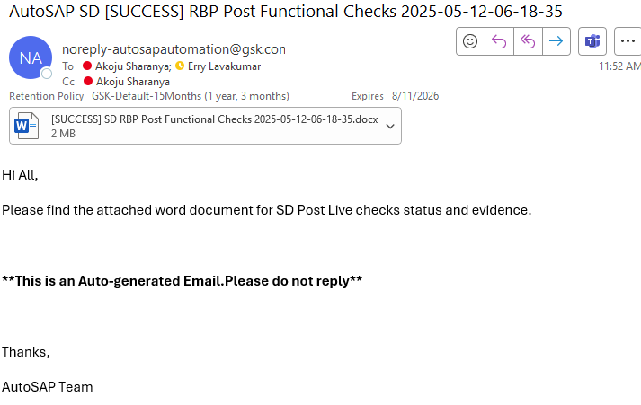 | 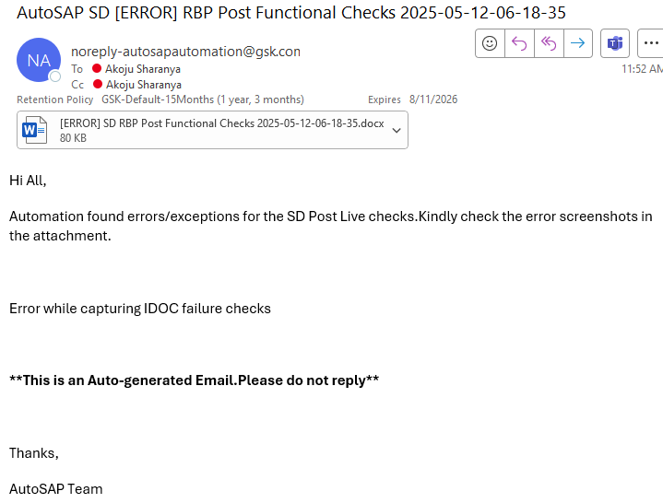

Appendix – Function Module Detail
NA
Appendix – Further Solution-specific sections
NA
Appendix – IDOC Detail
NA
Appendix – Data Dictionary Objects
NA
Appendix – Portal / Java Developments
NA
Appendix – Data
NA

